* **Backup Prerequisites:**
* Take the backup of current package Specification and body for SHAW_OM_POS_LGF_PKG for recovery process.
* Go to the URL:- <https://shawicsprod-a444774.integration.us2.oraclecloud.com/ics/>
* Enter the credentials and login
* Go to Task – Integrations – Designer – Integrations.
* Search for Integration – “**SHAW OM PointOfSales From Cloud to LogFire**” and **Export** the file as shown below.

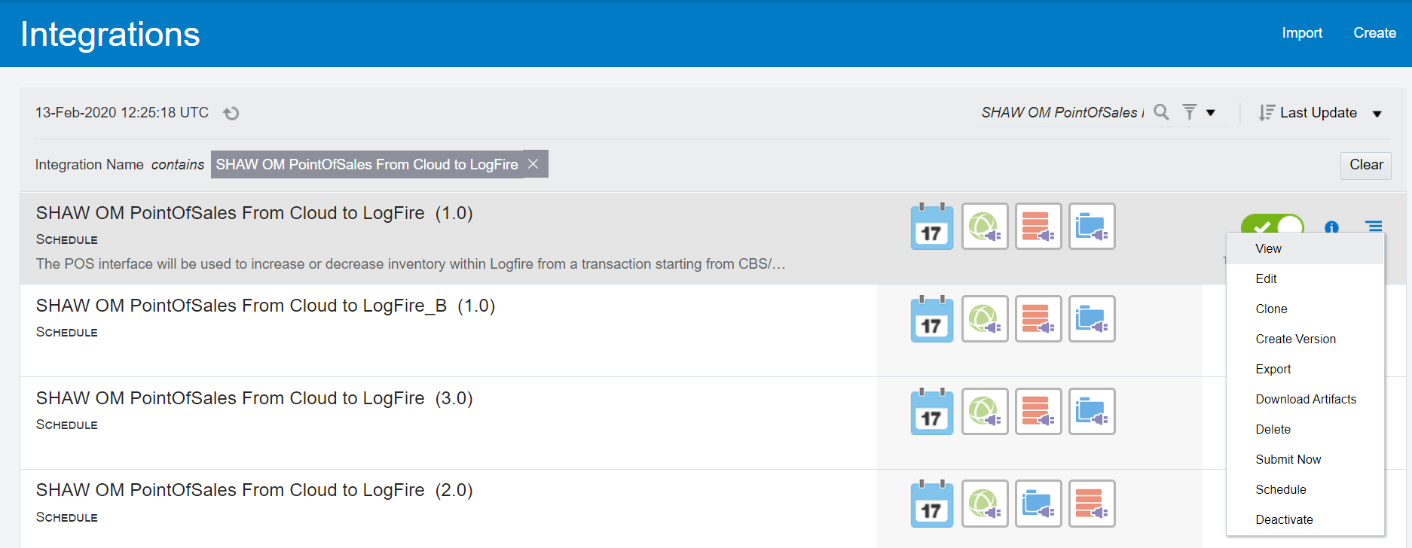



* Backup of the integrations is completed, and you can proceed with the migration.
* Search for Integration – “**SHAW OM PointOfSales From Cloud to LogFire**”
* Deactivate the Integration

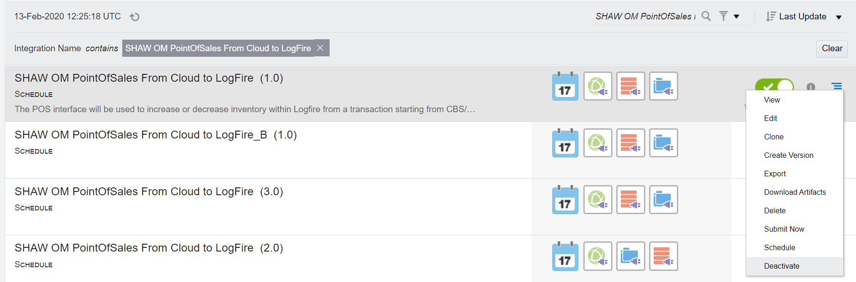



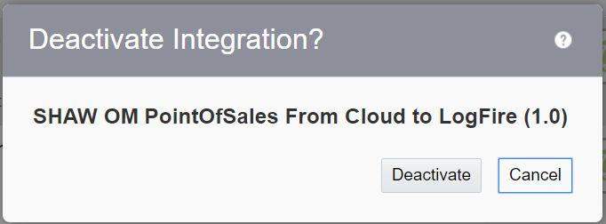



* **Installation:**
* Open Production DBCS connection in SQL Developer/Toad.
* Get the files from Git with below mentioned path and latest version
* Compile the package specification : cloud-erp\Interfaces\LOG-INT-18\Developed Components\DB\SHAW_OM_POS_LGF_PKG.pks
* Compile the package body : cloud-erp\Interfaces\LOG-INT-18\Developed Components\DB\SHAW_OM_POS_LGF_PKG.pkb
* Get the latest iar file from Git.

**cloud-erp\Interfaces\LOG-INT-18\Developed Components\ICS**

**SHAW_OM_POIN_FROM_CLOU_TO_LOGF_01.00.0000.iar**

* Go to the URL:- <https://shawicsprod-a444774.integration.us2.oraclecloud.com/ics/>
* Enter the credentials and login
* Go to Task – Integrations – Designer – Integrations and click Import 
* Select the .iar file and click import

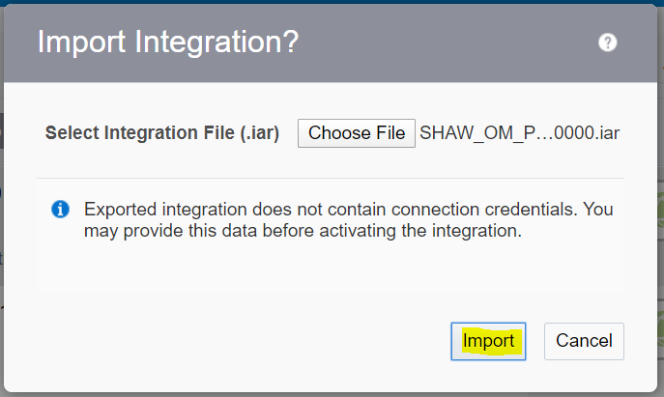

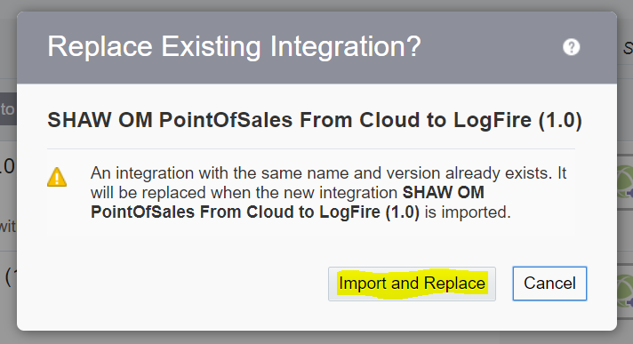

* Once imported Successfully, Activate the Integration

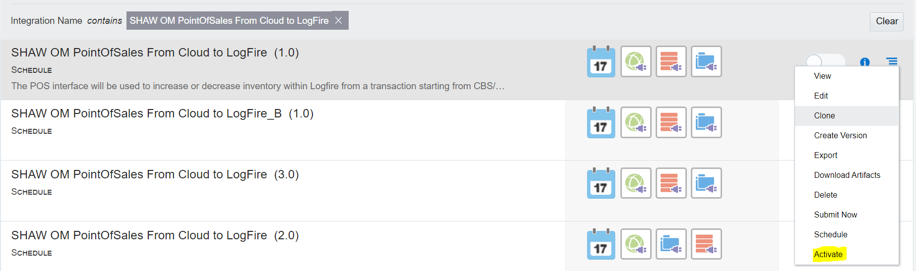

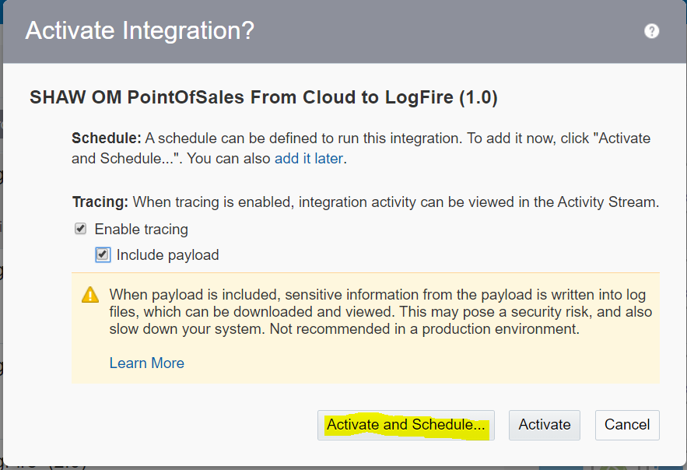

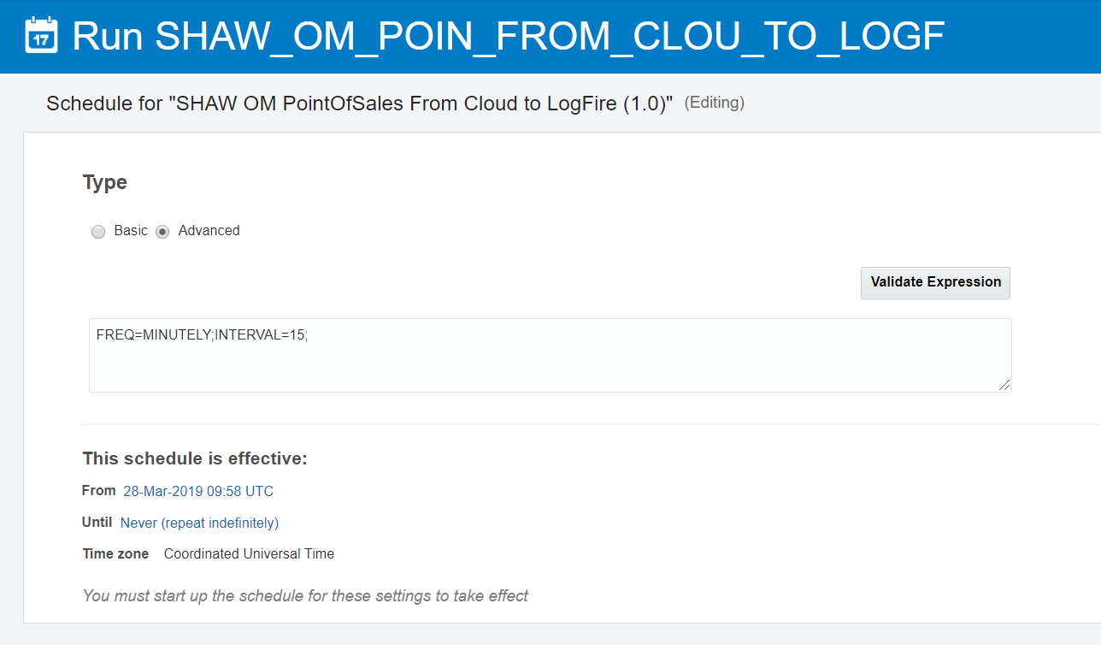

* **Recovery Steps**

In case of any issues follow the below steps to recover back to the old code. Use the backup code for the below steps.

* Compile the package specification and body for SHAW_OM_POS_LGF_PKG, taken as backup in in prerequisite steps.
* Like mentioned in the “**Installation**” steps import the below integration and activate it from backup code.

**SHAW OM PointOfSales From Cloud to LogFire**.